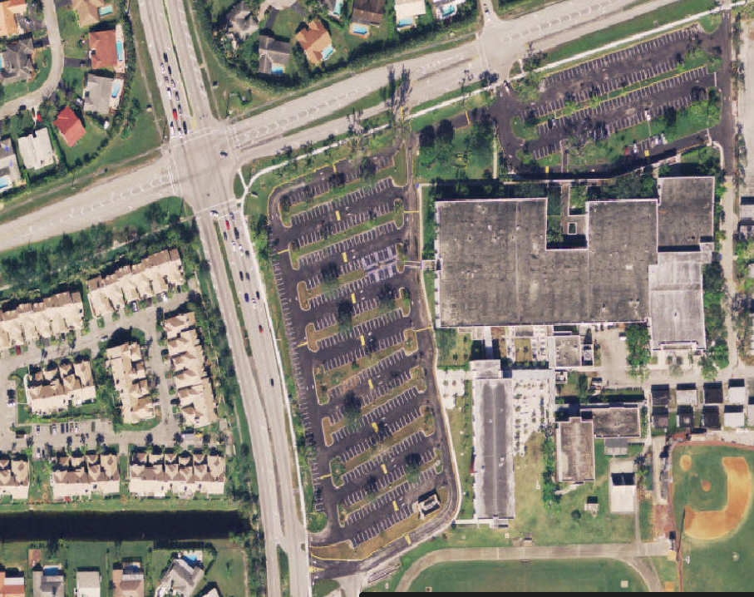

Riverside Dr.

Pine Island Rd./Coral Springs Dr.